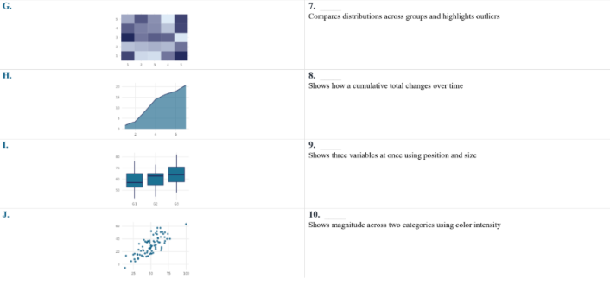
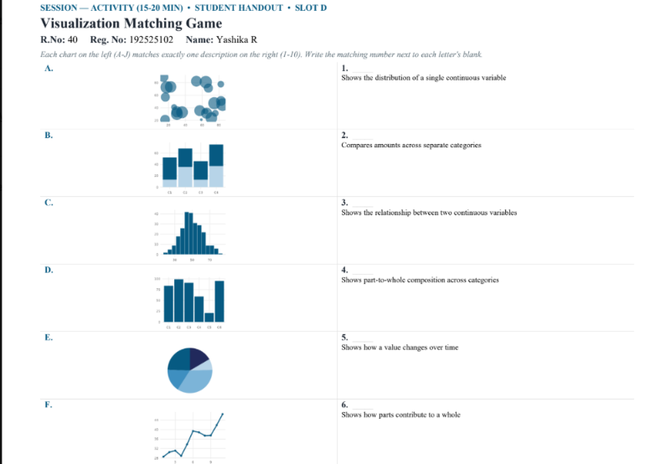

ANSWERS:
Chart | Answer
A | 9 – Shows three variables at once using position and size
B | 4 – Shows part-to-whole composition across categories
C | 1 – Shows the distribution of a single continuous variable
D | 2 – Compares amounts across separate categories
E | 6 – Shows how parts contribute to a whole
F | 5 – Shows how a value changes over time
G | 10 – Shows magnitude across two categories using color intensity
H | 8 – Shows how a cumulative total changes over time
I | 7 – Compares distributions across groups and highlights outliers
J | 3 – Shows the relationship between two continuous variables

Final matching:
A–9, B–4, C–1, D–2, E–6, F–5, G–10, H–8, I–7, J–3

